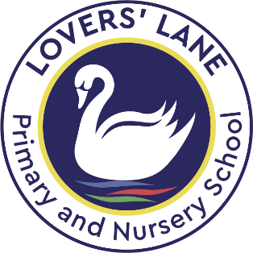

Celebration Assembly – Week Ending 17th November 2023
EYFS | Writer of the Week – Lara, tried really hard when retelling the story of ‘The Three Little Pigs’. Keep it up!  Reader of the Week – Emma for trying really hard in phonics this week. Keep it up!  Star of the Week – Jasmine, you’ve tried really hard this week. You are so kind and a super SWAN. We are really proud of you.
Year 1 | Reader of the Week – Julija for trying really hard with your phonics – keep it up!  Star of the Week – Leja for fantastic contributions to our whole class work this week. Keep it up Leja!
Year 2 | Star of the Week – Grace for being a super SWAN in all you do – keeping going.
Year 3 | Writer of the Week – Jacob for beautiful presentation in all his work but particularly in Personal Development. Well done!  Star of the Week – Arturas for remembering incredible details about making bronze in our History lesson. Amazing!
Year 4 | Writer of the Week – Maia for trying so hard with our grammar lessons.  Reader of the Week – Eduard for reading lots at home.  Star of the Week – Walter for lots of great contributions and always getting on with what is asked of him.
Year 5 | Reader of the Week – Ade for beautiful reading out in class.  Star of the Week – Doleja for aspiring to do well and great times tables improvement.
Year 6 | Writer of the Week – Matthew for your thoughtfulness in your blackout poem, considering the impact of your words.  Star of the Week – Callum for fantastic contributions in class this week.  Star of the Week – Sienna for demonstrating the school values, and showing courage in reading aloud.
School Awards | Diamond Powers cup winner for resilience – Brandon for working hard with Mrs Lambert.  Wisdom cup for independence – Jaxson for believing in himself and having a ‘can do’ attitude.

